The Project: A municipal sports council wants a website where people can find and book sports facilities such as tennis courts, football/soccer fields, and basketball courts.
Final system should allow:
Members
- Register an account
- Log in
- Enter personal information
- Select preferred sports
- Search for facilities
- Check availability
- Book a facility
- Submit a review after using it

Guests
- Browse facilities
- See general availability
- View reviews
- Register to become a member
- Send inquiries to the council
- Cannot access the full booking functionality without logging in

Sports Council
The database stores things such as:
- Members
- Facilities
- Sports
- Bookings
- Reviews
- Guest inquiries

The coursework has 5 major parts
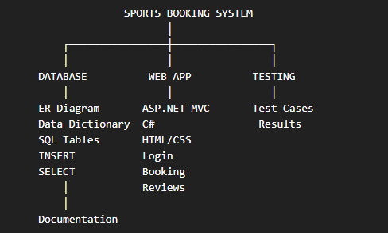
Database Design
- First design the database before building the website.
- Relational ER Diagram: Need to create an Entity Relationship Diagram
Database entities
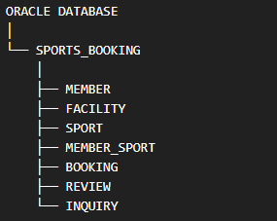

Relationships
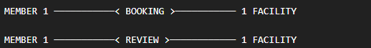

- One member can make many bookings.
- One facility can have many bookings.
- One member can write many reviews.
- One facility can receive many reviews.
SQL Developer Data Modeler
The assignment specifically wants to use: Oracle SQL Developer Data Modeler
to turn the database design into actual physical tables.

Workflow
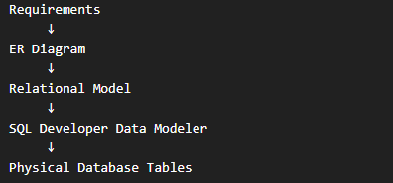

ASP.NET MVC Web Application
Build the website using: ASP.NET + C# + MVC
Prototype Includes
- Home Page – A central landing page introducing the Community Sports Facilities Booking System, displaying information about available community sports facilities and providing clear navigation for both registered members and guests.
- Facility Search – A search interface that allows users to find suitable sports facilities using criteria such as facility type, location, date, and preferred booking time. Search results can display the facility name, type, location, and general availability.
- Tennis Facilities – Dedicated facility listings for tennis courts, including information such as the court name, location, availability status, and basic facility details. Members can select a suitable tennis facility when making a booking.
- Football Facilities – Football/soccer field listings showing the available fields and relevant information such as location, facility type, and availability. The prototype allows these facilities to be included in the search and booking workflow.
- Basketball Facilities – Basketball court listings with basic facility information and availability. These facilities can be filtered through the main facility search interface.
- Date and Time Search – Date and time selection fields that allow members to specify when they want to use a facility. The system prototype demonstrates how the requested date and time can be used to identify suitable available facilities and reduce scheduling conflicts.
- Member Login – A member authentication interface where registered users can enter their email/username and password. Successful login provides access to member-only functionality such as detailed facility searches, bookings, and review submission.
- Member Registration – A registration form for new members to create an account by providing personal information such as name, email, contact details, address, password, and preferred sports. The prototype demonstrates the information that would later be stored in the database.
- Facility Reviews – A review interface allowing members to provide feedback after using a facility. Reviews can include a rating and written comment, while guests can browse previously submitted reviews to help them evaluate facilities.
- Guest / Restricted Access – The prototype distinguishes between guests and registered members. Guests can browse general facility information and reviews, but access to detailed booking functionality is restricted until they register and log in as members.
- Guest Inquiry Form – A contact/inquiry form allowing guests to send questions or requests to the municipal sports council. The form can collect information such as name, email address, subject, and message.
- Responsive Design – The interface is designed to adapt to different screen sizes, including desktop computers, tablets, and mobile devices, providing a consistent and accessible user experience.
- Interactive Prototype Functions – Interactive buttons, navigation elements, search controls, forms, booking actions, and notification/toast messages are included to demonstrate how the final application will behave. These prototype interactions provide a realistic representation of the planned system before connecting the interface to the actual ASP.NET MVC application and database.

Proposed Technical Stack
Category | Technology / Tool | Purpose
Frontend Framework | React.js | Build the interactive user interface and reusable components
Programming Language | TypeScript | Provide type-safe frontend development and improve code maintainability
CSS Framework | Tailwind CSS | Create responsive layouts, forms, cards, navigation, buttons, and overall styling
Icons | Lucide React | Provide consistent icons throughout the application
Backend Framework | ASP.NET Core MVC | Handle server-side application logic and follow the MVC architecture required by the coursework
Backend Language | C# | Implement controllers, business logic, validation, authentication, and database operations
Database | Oracle Database | Store members, facilities, bookings, reviews, sports preferences, and inquiries
Database Management | Oracle SQL Developer | Create, manage, query, and test the Oracle database
Database Modelling | Oracle SQL Developer Data Modeler | Create the ER diagram, relational model, and physical database design
Database Language | SQL | Create tables, relationships, constraints, insert data, and retrieve records
API Communication | REST API / HTTP | Allow the React frontend to communicate with the ASP.NET backend
API Data Format | JSON | Exchange data between React and ASP.NET
Authentication | ASP.NET Authentication | Manage member login and protected member functionality
Form Validation | TypeScript + ASP.NET Validation | Validate user input on both frontend and backend
Routing | React Router | Handle navigation between frontend pages
Development Environment | Visual Studio / VS Code | Develop the frontend and backend application
Package Management | npm | Install and manage React, TypeScript, Tailwind CSS and other frontend dependencies
Version Control | Git & GitHub | Track development changes and maintain the project source code
Testing | Browser DevTools + Visual Studio Debugger + SQL Developer | Test frontend, backend and database functionality

Main Architecture
